Polytechnic University of the Philippines
Quezon City Campus

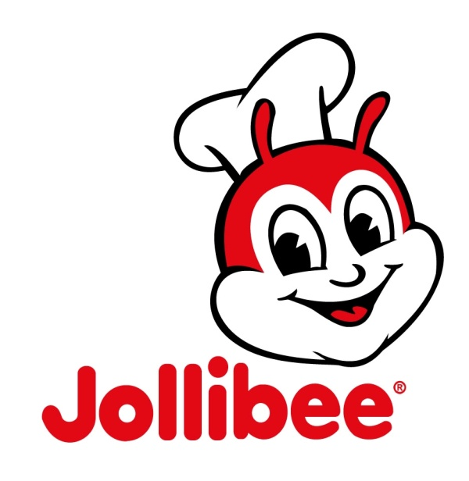
Project in Business Policy

Ayo, Lemuel C. Prof. Rosicar Escober
BSEM 4-1 Business Policy

“Jollibee Food Corporation”
Mission
To serve great tasting food, bringing the joy of eating to everyone.
Vision
We are the best tasting QSR.
The most endearing brand...
that has ever been...
We will lead in product taste at all times...
We will provide FSC excellence
in every encounter...
Happiness in every moment...
By year 2020, with over 4,000 stores worldwide,
Jollibee is truly a GLOBAL BRAND. (and the Filipino will be admired worldwide)
Introduction:
Jollibee is the largest fast food chain in the Philippines, operating a nationwide network of over 750 stores. A dominant market leader in the Philippines, Jollibee enjoys the lion’s share of the local market that is more than all the other multinational brands combined. The company has also embarked on an aggressive international expansion plan in the USA, Vietnam, Hong Kong, Saudi Arabia, Qatar and Brunei, firmly establishing itself as a growing international QSR player.
Jollibee Philippine provides us with the most delectable fast-food foods, but did you know that the Jollibee Philippine did not start on selling hamburgers or chickens. It was first started as an ice cream parlor at Cubao in 1975 by Tony Tan Caktiong with Jolibe as the original name selling ice creams rather than burgers. See what the Jollibee web site has to teach you if ever you wanted to know how to send some Jollibee food products to your family back home.
After several years, Tony, together with his siblings decided on getting the services of a management consultant in the person of Manuel C. Lumba. Lumba suggested that to shift their business of ice cream parlor to hamburgers after his studies showed that a much larger market was waiting to get tapped.
And sure enough, their hamburgers became a hit for a lot of Filipinos. After this success, Lumba next reformed the name Jolibe to Jolly Bee and made the two words form a single name Jollibee. Then Lumba next created the product name "Yumburger" as well as the name "Chickenjoy". See what the Jollibee web site has to teach you if ever you wanted to know how to send some Jollibee food products to your family back home.
Great Tasting Products and Quality Systems
Jollibee’s growth is due to its delicious menu line-up – like its superior-tasting Chickenjoy, mouth-watering Yumburger and Champ hamburger, and deliciously satisfying Jollibee Spaghetti -ably complemented with creative marketing programs, and efficient manufacturing and logistics facilities. It is made possible by well-trained teams that work in a culture of integrity and humility, fun and family-like. Every Jollibee outlet welcomes customers with a clean and warm in-store environment and friendly and efficient service.
And it is this tried and tested formula of delivering great-tasting food, adherence to world class operating standards and the universal appeal of the family values the brand represents that are driving the expansion of Jollibee both locally and in the overseas market.
Jollibee Products
- Jollibee Spaghetti
- Chickenjoy Dip'n Strips
- Jolly Crispy Fries
- Breakfast Joys Beef Tapa
- Breakfast Joys Breakfast Steak
- Breakfast Joys Corned Beef
- Breakfast Joys Hotdog
- Breakfast Joys Longganisa
- Breakfast Joys Pancakes
- Burger Steak
- Caramel Pastillas Sundae
- Champ 1/3 Pound Beef Patty
- Chicken Joy
- Creamy Macaroni Soup
- Crispy Chicken Burger
- Ice Craze
- Jollibee 39ers
- Jolly Frost Blends Chocolate Jelly
- Jolly Frost Blends Strawberry Cream
- Jolly Hotdog Classic
- Jolly Kruncy Twirl Chocolate
- Palabok Fiesta
- Pancake Sandwich
- Spicy Chicken Joy
- Sundae Chocolate
- Tuna Pie
- Yum
- Yum with cheese and TLC
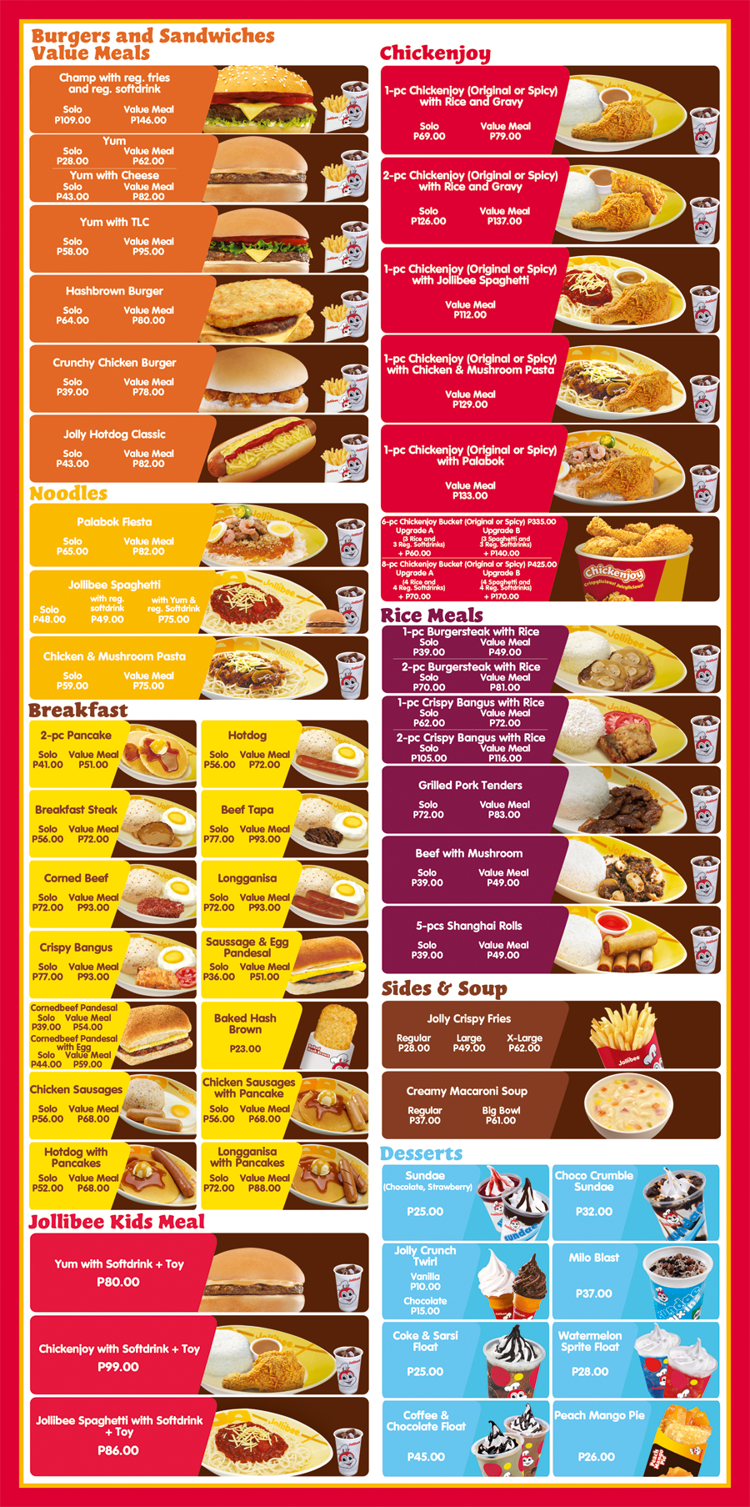

Products of Jollibee

Goals: A Well-Loved Brand
Customer satisfaction has always been key to Jollibee’s success. Never losing sight of its goals, Jollibee has grown to be one of the most recognized and highly preferred brands in the Philippines. Now the market leader among fast food chains in the Philippines, claiming a market share that totals to more than half of the entire industry.

Widest store network in the Philippines and an emerging global player
Jollibee is the largest fast food chain in the Philippines, operating a nationwide network of more than 750 stores. A dominant market leader in the Philippines, Jollibee enjoys the lion’s share of the local market that is more than all the other multinational brands combined. The company has also embarked on an aggressive international expansion plan, and currently has 80 stores outside the Philippines-USA (26), Vietnam (32), Brunei (11), Jeddah (7), Qatar, Hong Kong, and Kuwait (1 each), firmly establishing itself as a growing international QSR player.

A Triumph for and of the Filipino and a source of Filipino pride.
Jollibee dedicated its continuous success to the Filipinos who have been there from the very start.Jollibee is so well-loved everytime a new store opens, especially overseas, Filipinos always form long lines to the store. It is more than home for them. It is a stronghold of heritage and monument of Filipino pride.
SERVICES:
- Dial 8-7000 Jollibee Delivery
- Get fresh, complete and affordable meals, anytime, anywhere through 8-7000 Jollibee express Delivery Service. Whether you find yourself stuck indoors or craving for Jollibee treat, dial 8-7000 and enjoy Jollibee’s extensive menu of tasty Filipino food.
- Jollibee Drive Thru
- When hunger strikes you on the road, turn to Jollibee Drive Thru. With the most number drive thru outlets in the country, Jollibee awaits hungry motorists wherever they may be. So why stop when the hunger starts. Get any of your langhap sarap favorites fast anytime, anywhere. For sarap on the go, mag Jollibee drive thru.
- Jollibee Kids Party
- Looking for the best way to make your child’s birthday extra special? Throw a Jolly Kiddie Party! It’ll be fun. It’ll be enjoyable and it’ll be absolutely memorable.
- Open 24 Hours
- Jollibee is awake for 24 hours to serve you with Langhap-Sarap goodness. Open all day and all night, Jollibee’s 24 hour service allow you to enjoy your Jollibee favorites even in the wee hours of the morning. Sa mga lagging gising tulad mo, lagging gising ang Jollibee.

Industry Analysis
A fast food restaurant or Rapid Service Eatery (RSE) has the following 3 characteristics.
1. It is characterized by its fast food cuisine and nominal table service.
2. It offers limited menu, cooked in bulk in advance, kept hot, finished, packaged to order, and available to take-out, drive-thru, and dine-in.
3. It is usually a part of a chain or franchise operation, which supplies standardized ingredients and/or partially prepared foods and provisions to each restaurant through controlled supply channels.
McDonald's is one of the most famous RSE in the world. McDonald's became No.1 in every country of more than 100 countries in the world except Philippines where JFC has been overwhelming strength against McDonald's.
JFC was founded by Chinese-Filipino Mr. Tony Tan Caktiong (TTC) as the ice-cream parlor at Cubao City in 1975. Gradually, it grew up to a reasonably large fast food chain in Philippines.
Further, JFC started scouting avenues for expansion internationally. Thus it opened its franchises in countries like U.S.A., Brunei, Hong Kong, Guam, Middle East, etc.
Assuming, Mc Donald's was the chief competitor of JFC in Philippines we have made an analysis of the strategies adopted by both the organizations.
In order to analyze the strategy, we have utilized the following two tools.
a) Four-Tier Structure of Market
b) Type of Glocalization

A. FOUR-TIER STRUCTURE OF MARKET
Khanna &amp; Palepu (2006) introduced the Four-Tiered Structure of Market. They insisted that most product markets comprise four distinct tires: global, glocal, local, and regional.
In Global segment, products of global quality with global features at global prices are offered. In Glocal segment, products of global quality with local features (and local soul) at less than global prices are offered. In local segment, local products with local features at local prices are offered.
B. TYPE OF GLOCALIZATION
As objectives of glocalization can be product/service and business model, there are two types of glocalization.
- Product/service glocalization
- Business model glocalization.
The following charts give an overview of strategies adopted by JFC and Mc Donald's.
a. Porter's competitive strategies Model
b. Type of Glocalization (Products/Services vs. Business Model)
b. Firm Analysis
SWOT ANALYSIS OF JFC:
Strengths and Weaknesses
a. Jollibee was a regional industry leader that had experienced professionals as chief executives of the organization.
b. Proven past performance made dealings with prospective partners easier.
c. Wide variety of products offered in diverse markets.
a. Lacked more effective marketing skills as growth revenues decreased.
b. Lack on in-depth planning and research in the expansion to foreign markets.
c. Poor co-ordination between the national and international units.

OPPORTUNITIES THREATS
a. The promising nature of international markets and also the available potential due to the migration of Filipinos in certain countries.
b. Being an agricultural country, full integration in sourcing raw materials could be done.
c. For international markets, locating commissaries in the same country through joint ventures could be a potential source of success for the company. Jollibee could facilitate the technology provision while the partner could formulate the appropriate modus operandi to sell in the foreign market.
d. For the local market, an increase in the number of commissaries could easily reduce the transportation costs and the duration of shipments. This would allow the company to concentrate on the quality of products.
a. Competition from both international companies and other local eateries.
b. Political instability in the country threatened JFC as it could hamper the opportunities to convince international investors and country leaders to allow a JFC entry in their country.
c. Driving Forces
Analysis of Tony Kitchner's Strategy
a. Marketing Perspective
Jollibee was able to attain a competitive advantage in Philippines over McDonald's by doing following things:
• First mover advantage - Jollibee was the first to enter the market.
Analysis of Tony Kitchner's Strategy
In 1994 Tony Kitchner was hired to head the International Division. He was successful over his three years. He was successful in creating wealth and increasing the presence in countries that had less or no competition. During his time the total number of stores increased 65% to 205 from the end of 1993 to the end of 1996. Moreover the total sales increased over 94.5% over the same period These increases are dramatic. Very few companies can experience rapid growth like this. He always had the idea to be the first -mover into untapped markets as he believed that although you may incur losses in the initial years, which can be cross subsidized from Philippines operation, the company will be able to restrict the entry of its competitors. But these do not show the whole picture of his strategy implementation. There were instances of shutdown of stores due to mounting losses .The chaotic strategy of investments unsupported by proper research failed costly for the company. His strategy of targeting expats had the risk of targeting a narrow segment. The lifestyle, tastes and preferences of the expats was also not considered during international expansion.

Jollibee was able to attain a competitive advantage in Philippines over McDonald's by doing following things:
• Jollibee was the first to enter the market.
• Retaining tight control over operations management, which
• Allowing it to price below its competitor.
• Having the flexibility to cater to the tastes of its local consumers.
As Jollibee entered international markets, it faced new challenges. The fast food industry is highly competitive and price wars and marketing innovations are seen frequently. The rivalry is also centered on the key success factors of the industry, which are good food, good, service and reasonable pricing. Rivals are somewhat equal in capabilities and opportunities, thus making the competition stiffer. Internationally well-established players like KFC and McDonalds had high brand values that Jollibee found difficult to compete with. The threat of substitute products is considerable. Local street food and high-end restaurants form two ends of a range of substitutes. Potential entrants face entry barriers that will hinder them from entering the industry. These are the inability to gain access to technology and specialized know-how, brand preference and customer loyalty, capital requirements, economies of scale, and strategically situated distribution channels.
Tony Kitchner was hired to build the global Jollibee brand with the dual goals of positioning Jollibee as an attractive partner, while generating resources for expansion. In order to become one of the &amp;quot;top 10 fast food brands in the world,&amp;quot; Kitchner implemented a two-part international strategy which comprised of &amp;quot;targeting expats&amp;quot; and &amp;quot;planting the flag.&amp;quot;
TARGETING EXPATS
Allows the company to ease its transition into an unfamiliar market. Although there is the risk of targeting too narrow of a segment, Jollibee's success in the niche market would allow it generate momentum for the company's expansion. The concentrated marketing campaign allows the company to generate stable revenues that can be used to support Jollibee's entry into other segments, while the popularity amongst expats could generate publicity and attract walk-in traffic from non-Filipinos.

Recommendation
Market research prior to entering new markets will help in avoiding the unprofitable ventures as in the Middle East. In order to compete on the level with multinationals, rather than just being a first mover, Jollibee would have to take its performance to the next step and prove that it could continue to build its competitive advantage.
• International operations should be completely separated from domestic ones.
• Strategy of varying the menu to local taste should be implemented.
• Smooth supply chain management system should be put in place to increase efficiency and productivity.
• In case of expanding the menu, economies of scale and operational efficiency should be kept in mind.
• Some items which increase inefficiency should be removed from the menu.

Financial Management Perspective
Jollibee's sales, net income, operating income, and royalties and franchise fees has been increasing rapidly for the period under study. The total number of stores increased 65% to 205 from the end of 1993 to the end of 1996. By 1996, sales had increased to 8.57 billion which translates to a market share of more than 50% among all hamburger fast food chains. Total assets increased over 230% in the same period. Moreover operating income increased about 114% while net income increased over 100% during the same period. These increases are dramatic. Significantly Inventory decreased from about 11.5% in 1992 to just 7.5% in 96. This implies that less of the current assets were tied up inventory. During the same period the trade accounts receivables has increased from 8.4% in 1992 to 12.7% in 1996. Jollibee was able to compensate for this increase by corresponding increase in sales and hence this need not be a cause of concern.
On the other hand, all is not well with the financials of Jollibee. There was 28.9 million pesos of long-term debt outstanding at the end of year 1996. Cost of sales has increased each year with an increase of about 46% from the end of 95 to the end of 96. But during this same period, total sales only increased about 28.7%. This escalation in the cost of sales must be brought under control. Accounts payable and accrued expenses increased by about 156% from 94 to 96. In addition, earnings per share decreased 19% to 0.68 pesos per share from 94 to 96. Jollibee has debt and some financial instability; however it is not something they can't overcome. They have 24 stores in foreign countries, which account for roughly $9 million in sales. This is an encouraging sign as far as Jollibee is concerned and they will be able to pay off their debts and loans.
One thing they should consider doing is slowing down expansion. Jollibee should consider opening a store and giving it time to grow and turn a profit before it finances the opening of a new store. Opening new stores requires a lot of financing. They must study markets to determine a location, buy furniture, purchase kitchen appliances, and train new managers and employees. Opening multiple stores at the same time will hurt the bottom line and will increase debt. It took McDonald's 20 years for their international operations to account for 50% of total sales. Also, they must reduce cost of sales. During the period under study the cost of sales has increased at a faster pace than the sales increase, which is not acceptable.
The company has good internal financial resources but a certain code should be maintained in the relationship with the franchisee. Also, the allocation of the financial resources needs to be done wisely and judiciously. This is where there has to be collaboration between the marketing and finance department. The feasibility (financial) of opening up a new store needs to be studied before going ahead with the decision.

Implementation Plan
a. New product-new market
JFC could introduce new product develop targeting the foreign market. The new products that they had introduced in the Philippines could also be applicable to the international market. These stores should be particularly targeted towards the Filipinos working overseas.
b. Increase depots in the domestic and other countries
JFC could establish additional depot near Jollibee stores. Through this, they could be able to reduce logistics costs thus leading to cost efficiency.
Such a measure will ensure the freshness and high quality of the products that they will deliver to the international stores. In addition, they could avoid high shifting cost from the Philippines to other countries.
They can also enter into joint venture agreement with other country in establishing new depot abroad. That is for JFC to be able to have ready knowledge about the external factors governing the country.
c. Maintaining market dominance
To attain market dominance, Jollibee should concentrate on increasing the presence in international markets. The international market will only need a good communication plan like tailor made ads, PR articles, good promotional plans in getting the newly introduced products known, and focusing on pushing products, getting it known, and creating loyal customers. Besides, the transfer of the local taste buds would not be that quick going to international markets.
Also, the company should improve on its research and development from new markets, potential acquisitions and new products to be developed. For each of the other business units, JFC should communicate the company culture through company conventions to ensure that the company interests are achieved. Advertising campaigns though do not always have to be Jollibee sponsored. As a suggestion, the other business units should focus on environment publicity, compared to Jollibee's ads for humanity and youth.
As the macro environment changes, the company should be responding by aligning its strategy and structure according to these changes. The group feels that company should take baby steps rather than the aggressive steps as those taken by Kitchner, owing to the financial constraints .The company should try to ride on the learning curve and experience from different markets. The company should try to resolve the internal conflicts and should have a focused vision.
Policies that Jollibee must always have:
While there are many simple ones they can vary depending on if you are going through drive-thru or coming inside. If you do go inside, the main policies are to always greet the customer in a timely manner. Take the order, repeat it back to them, suggestive sell if possible, and have the order packed or pack it yourself. Always thank them and wish them a great day. If going through drive-thru the process is a little more complicated. You must greet the customer within 5 seconds of the customer reaching the intercom, take the order, repeat it back, suggestive sell, thank them ask them to pull forward. You must answer the window with a Hi, tell them the total due, cash it out, give the change due with food and thank them again, wishing them a great night. All product must be within acceptable guidelines and a drive thru order should take no longer then 3 minutes to execute for maximum efficiency.
Policies to be Recommend to Jollibee Foods Corporation
- Serve the Best Quality of foods.
- One view of quality is that it is defined entirely by the customer or end user, and is based upon that person's evaluation of his or her entire customer experience. The customer experience is defined as the aggregate of all the interactions that customers have with the company's products and services. For example, any time one buys a product, one forms an impression based on how it was sold, how it was delivered, how it performed, how well it was supported etc.
-Sometimes Jollibee Store serves imperfect foods like under portioning of food standard and etc. The Jollibee did not satisfy the costumer so it will affect the target market which it is the costumer. It will decrease the sales cause of bad serving of foods so serve the best quality of foods.
2. Costumer Relation (treat all costumer equal)
- Customer relations are the relationships that a business has with its customers and the way in which it treats them. Either it is poor or rich; they must treat the costumer equal. In Jollibee, they treat costumers according to the level.

